**Life expectancy using Machine Learning**

**Project Report**

1. **INTRODUCTION**
   1. **Overview**

The Machine Learning model is built on Jupyter notebook in IBM Watson Studio using Python programming language, this model works as backend, the front-end (User Interface) i.e. Web Page is built using Node-Red that too through IBM Cloud. On the Webpage, the inputs are to be provided and after submitting the details, the predicted value of expected life is displayed in real time.

* 1. **Purpose**

The project tries to create a model based on data provided by the World Health Organization (WHO) to evaluate the life expectancy for different countries in years.

1. **LITERATURE SURVEY**
   1. **Existing problem**

Life expectancy plays an important role when decisions about the final phase of life need to be made but prediction of life expectancy by clinicians and researchers shows a variety of prediction and also it took a lot of time to predict.

* 1. **Proposed solution**

A Machine Learning model can predict the Life Expectancy very accurately, that too in small amount of time.

1. **THEORITICAL ANALYSIS**
   1. **Block diagram**

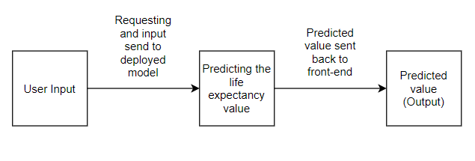

* 1. **Hardware / Software designing**
* **Hardware**

Hardware used for this model are on IBM Cloud, any desktop/PC or Laptop with good internet connection is compatible.

* **Software**

In software front, the front-end of the model is a Web form build using node red, which is integrated with back-end which is building and deployed using Jupyter notebook and IBM Cloud Services.

1. **EXPERIMENTAL INVESTIGATIONS**

The model is using Random Forest Regressor, after changing different parameters the best possible pair found is

(n_estimators = 100, oob_score = True, min_samples_leaf = 1, random_state = 0)

1. **FLOWCHART**

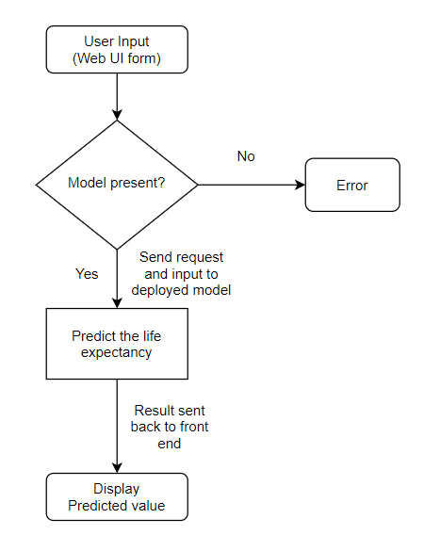

1. **RESULT**

The result which will be displayed on the web UI is the predicted life expectancy of that country.

1. **ADVANTAGES & DISADVANTAGES**

* **Advantage**

The Model is fast and accurate (96% accuracy)

* **Disadvantage**

The model follows the trend in data which is of past 15 years of each country, so any change in the trend will give less accurate result.

1. **APPLICATIONS**

Predict the average life expectancy of a person in a given country on a given year based on a number of variables.

1. **CONCLUSION**

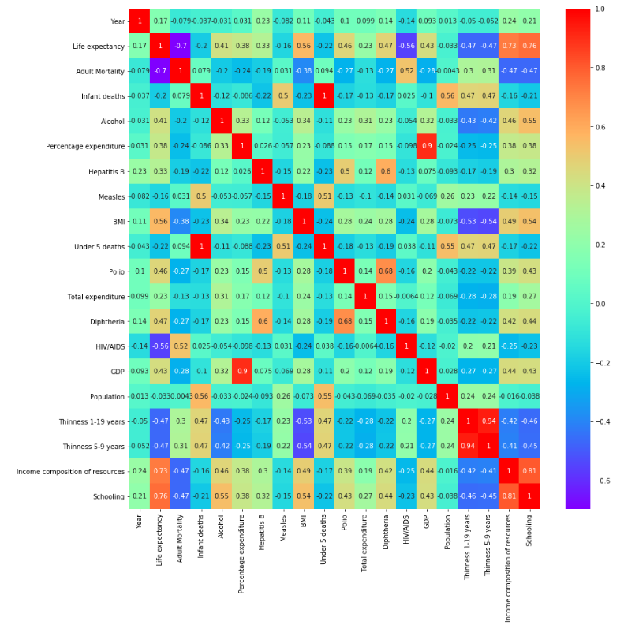

By plotting the correlation between different variables we can observe that Life expectancy mostly related to schooling and income composition

1. **FUTURE SCOPE**

The model can be easily implemented under various situations, we can add more attributes for better understanding the features relation and adding more data of present years will make model more accurate.

1. **BIBILOGRAPHY**

* [www.youtube.com](http://www.youtube.com)
* [www.nodered.org](http://www.nodered.org)
* [www.ibm.com/cloud](http://www.ibm.com/cloud)
* [www.bookdown.org](http://www.bookdown.org)
* [www.kaggle.com](http://www.kaggle.com)

1. **APPENDIX**
   1. **Source code**

Life Expectancy.ipynb